PA Instate 1000
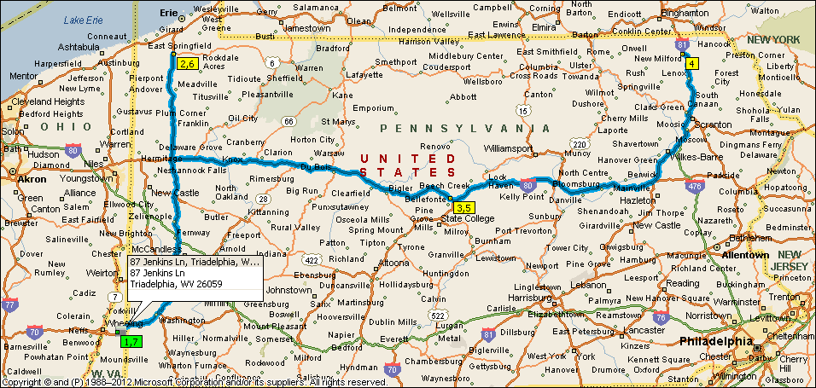
Summary: 1028.5 miles (14 hours, 57 minutes)
Time | Mile | Instruction | For | Toward
5:00 AM | 0.0 | Depart 6 Cabela Dr, Triadelphia, WV 26059 on CR-65 [Cabela Dr] (East) | 0.3 mi
5:00 AM | 0.3 | Take Ramp (LEFT) onto I-70 | 21.9 mi | I-70 E / Washington Pa
5:05 AM | 4.9 | Entering Pennsylvania
5:20 AM | 22.2 | At exit 18, take Ramp (RIGHT) onto I-79 [Raymond P Shafer Hwy] | 128.3 mi | I-79 N / Pittsburgh
7:13 AM | 150.5 | At exit 166, turn RIGHT onto Ramp | 0.4 mi | US-6N / Edinboro / Albion
7:14 AM | 150.9 | Turn RIGHT (East) onto US-6N [Route 6N] | 164 yds
7:14 AM | 150.9 | Turn LEFT (North) onto Local road(s) | 10 yds
7:15 AM | 151.0 | Turn LEFT (West) onto US-6N [Route 6N] | 43 yds
7:15 AM | 151.0 | At 5930 Route 6N, Edinboro, PA 16412, stay on US-6N [Route 6N] (West) | 0.2 mi
7:15 AM | 151.2 | Turn LEFT (South) onto Local road(s) | 10 yds
7:15 AM | 151.2 | Take Ramp onto I-79 [Raymond P Shafer Hwy] | 49.3 mi | I-79 S / Pittsburgh
7:57 AM | 200.5 | At exit 116A, take Ramp (RIGHT) onto I-80 [ZH Confair Memorial Hwy] | 138.1 mi | I-80 E / Clarion
9:54 AM | 338.6 | At exit 158, turn RIGHT onto Ramp | 0.3 mi | PA-150 / Milesburg
9:55 AM | 338.9 | Keep LEFT to stay on Ramp | 21 yds | PA-150 N / Lock Haven
9:55 AM | 338.9 | Bear LEFT (South-East) onto Local road(s) | 21 yds
9:55 AM | 338.9 | Turn LEFT (East) onto PA-150 [N Eagle Valley Rd] | 0.9 mi
9:56 AM | 339.8 | At N Eagle Valley Rd, Milesburg, PA 16853, return South-West on PA-150 [N Eagle Valley Rd] | 0.4 mi
9:56 AM | 340.3 | Road name changes to US-220 ALT [PA-150] | 0.4 mi
9:57 AM | 340.6 | Take Ramp onto I-80 [US-220 ALT] | 102.3 mi | US-220-ALT N / I-80 E
11:23 AM | 443.0 | At exit 260B, take Ramp (LEFT) onto I-81 | 23.8 mi | I-81 N / Wilkes-Barre
11:46 AM | 466.8 | At exit 175, take Ramp (RIGHT) onto PA-315 [Highway 315] | 0.5 mi | PA-315 N / I-476 / Pittston / Dupont / Penna Turnpike
11:46 AM | 467.3 | *Toll road* Keep RIGHT onto Ramp | 0.4 mi | I-476 / Pennsylvania Turnpike
11:47 AM | 467.6 | *Toll road* Take Ramp (LEFT) onto I-476 [Pennsylvania Tpke Northeast Ext] | 16.6 mi | I-476 / Scranton
12:02 PM | 484.2 | *Toll road* Turn RIGHT onto Ramp | 0.2 mi | US-6 E / I-81 S / I-380 / I-84 / Wilkes-Barre
12:03 PM | 484.5 | Stay on Ramp (East) | 32 yds
12:03 PM | 484.5 | Take Ramp (LEFT) onto I-81 | 29.8 mi | I-81 N / Beighamton
12:29 PM | 514.3 | At exit 223, turn RIGHT onto Ramp | 0.3 mi | PA-492 / Lakeside / New Milford
12:30 PM | 514.6 | Turn LEFT (West) onto PA-492 | 0.6 mi | PA-492 W / US-11
12:31 PM | 515.2 | At 96 Jackson St, New Milford, PA 18834, return East on PA-492 [Jackson St] | 0.5 mi
12:31 PM | 515.8 | Take Ramp (RIGHT) onto I-81 | 29.9 mi | I-81 S / Scranton
12:57 PM | 545.7 | At exit 194, keep RIGHT onto Ramp [Clarks Summit Interchange] | 0.2 mi | I-476 S / US-6 W / US-11 / Penna Turnpike / Clarks Summit
12:57 PM | 545.9 | *Toll road* Take Ramp (RIGHT) onto I-476 [Pennsylvania Tpke Northeast Ext] | 15.9 mi | I-476 S / Allentown / Penna Turnpike
1:11 PM | 561.8 | *Toll road* At exit 115, keep RIGHT onto Ramp [Wyoming Valley Interchange] | 0.6 mi | PA-315 / I-81 / Pittston / Wyoming Valley
1:12 PM | 562.4 | *Toll road* Keep LEFT to stay on Ramp | 0.3 mi | PA-315 S / I-81 S / Wilkes Barre
1:13 PM | 562.7 | Merge onto PA-315 [Highway 315] | 0.5 mi
1:14 PM | 563.3 | Take Ramp (RIGHT) onto I-81 | 23.8 mi | I-81 S / Hazleton
1:36 PM | 587.0 | At exit 151B, take Ramp (LEFT) onto I-80 | 102.3 mi | I-80 W / Bloomsburg
3:02 PM | 689.4 | At exit 158, turn RIGHT onto Ramp | 0.3 mi | PA-150 / Milesburg
3:03 PM | 689.6 | Keep STRAIGHT to stay on Ramp | 54 yds | PA-150 N / Lock Haven
3:03 PM | 689.7 | Keep STRAIGHT onto Local road(s) | 21 yds
3:03 PM | 689.7 | Turn LEFT (East) onto PA-150 [N Eagle Valley Rd] | 0.4 mi
3:04 PM | 690.1 | At N Eagle Valley Rd, Milesburg, PA 16853, return South-West on PA-150 [N Eagle Valley Rd] | 0.4 mi
3:04 PM | 690.5 | Keep RIGHT onto Ramp | 0.2 mi | I-80 W
3:04 PM | 690.7 | Take Ramp (RIGHT) onto I-80 | 137.6 mi
5:01 PM | 828.3 | At exit 19B, take Ramp (RIGHT) onto I-79 [Raymond P Shafer Hwy] | 49.0 mi | I-79 N / Erie
5:42 PM | 877.3 | At exit 166, turn RIGHT onto Ramp | 0.4 mi | US-6N / Edinboro / Albion
5:43 PM | 877.7 | Turn RIGHT (East) onto US-6N [Route 6N] | 164 yds
5:43 PM | 877.8 | Turn LEFT (North) onto Local road(s) | 10 yds
5:43 PM | 877.8 | Turn LEFT (West) onto US-6N [Route 6N] | 43 yds
5:44 PM | 877.8 | At 5930 Route 6N, Edinboro, PA 16412, stay on US-6N [Route 6N] (West) | 0.2 mi
5:44 PM | 878.0 | Turn LEFT (South) onto Local road(s) | 10 yds
5:44 PM | 878.0 | Take Ramp onto I-79 [Raymond P Shafer Hwy] | 128.0 mi | I-79 S / Pittsburgh
7:37 PM | 1006.1 | At exit 38, take Ramp (RIGHT) onto I-70 | 22.0 mi | I-70 W / Wheeling
7:53 PM | 1023.7 | Entering West Virginia
7:56 PM | 1028.1 | At exit 10, turn RIGHT onto Ramp | 0.4 mi | CR-65 / Cabela Dr.
7:57 PM | 1028.4 | Turn RIGHT (West) onto CR-65 [Cabela Dr] | 54 yds
7:57 PM | 1028.5 | Arrive 6 Cabela Dr, Triadelphia, WV 26059

SUMMARY
Driving distance: 1028.5 miles
Trip duration: 14 hours, 57 minutes
Driving time: 14 hours, 57 minutes
Cost: $114.28

OH Instate 1000
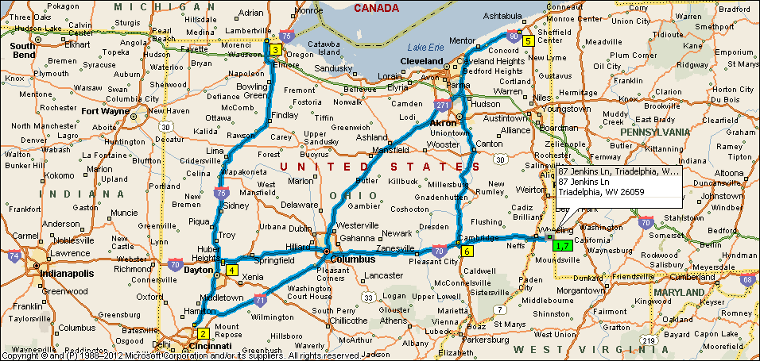
Summary: 1036.0 miles (15 hours, 11 minutes)
Time | Mile | Instruction | For | Toward
5:00 AM | 0.0 | Depart 87 Jenkins Ln, Triadelphia, WV 26059 [87 Jenkins Ln, Triadelphia, WV 26059] on CR-41/2 [Jenkins Ln] (North) | 0.1 mi
5:00 AM | 0.1 | Turn RIGHT (East) onto Ramp | 0.2 mi
5:00 AM | 0.3 | Turn LEFT (West) onto CR-41 [Dallas Pike Rd] | 0.1 mi
5:00 AM | 0.5 | Take Ramp (LEFT) onto I-70 | 5.9 mi | I-70 W / Wheeling
5:06 AM | 6.3 | At exit 5A, take Ramp (LEFT) onto I-470 | 10.6 mi | I-470 W / Columbus
5:10 AM | 10.3 | Entering Ohio
5:15 AM | 17.0 | At exit 1, take Ramp (LEFT) onto I-70 | 39.5 mi | I-70 W / Columbus
5:49 AM | 56.5 | At exit 180B, take Ramp (RIGHT) onto I-77 | 2.1 mi | I-77 N / Cleveland
5:51 AM | 58.6 | At exit 46B, turn RIGHT onto Ramp | 0.4 mi | US-40 W / Cambridge
5:51 AM | 59.0 | Keep STRAIGHT onto US-40 [Wheeling Ave] | 0.4 mi
5:52 AM | 59.3 | Keep STRAIGHT onto US-40 [E Wheeling Ave] | 0.9 mi
5:54 AM | 60.2 | Turn LEFT (South-West) onto US-22 [US-40] | 2.7 mi
5:58 AM | 62.9 | Turn LEFT (South) onto OH-723 | 0.2 mi
5:59 AM | 63.2 | Take Ramp onto I-70 | 18.8 mi | I-70 W / Columbus
6:15 AM | 82.0 | At exit 157, turn off onto Ramp | 0.3 mi | OH-93 / Adamsville / Zanesville
6:15 AM | 82.3 | Turn LEFT (South) onto OH-93 [Pleasant Grove Rd] | 0.2 mi
6:15 AM | 82.4 | Turn RIGHT (West) onto US-22 [US-40] | 2.3 mi
6:19 AM | 84.7 | Turn RIGHT (North) onto OH-146 [OH-60] | 0.3 mi
6:20 AM | 85.0 | Take Ramp (LEFT) onto I-70 | 49.5 mi | I-70 W / Columbus
7:02 AM | 134.5 | At exit 105A, turn RIGHT onto Ramp | 0.3 mi | US-33 / Lancaster
7:03 AM | 134.8 | Bear RIGHT (South) onto S James Rd | 0.5 mi
7:03 AM | 135.3 | Take Ramp onto US-33 | 0.5 mi
7:04 AM | 135.7 | Keep RIGHT onto Ramp | 0.2 mi | OH-104 W / Refugee Rd
7:04 AM | 135.9 | Take Ramp (RIGHT) onto OH-104 | 5.0 mi | OH-104 W / Refugee Rd West
7:09 AM | 140.9 | Keep STRAIGHT onto Frank Rd | 0.4 mi
7:09 AM | 141.3 | Take Ramp (LEFT) onto I-71 | 70.9 mi | I-71 S / Cincinnati
8:09 AM | 212.2 | At exit 32, turn RIGHT onto Ramp | 0.3 mi | OH-123 / Morrow / Lebanon
8:09 AM | 212.5 | Turn RIGHT (North) onto OH-123 [S OH-123] | 3.4 mi
8:14 AM | 215.9 | Road name changes to OH-63 [W Main St] | 7.0 mi
8:21 AM | 222.8 | Turn LEFT (South) onto Local road(s) | 10 yds
8:21 AM | 222.8 | Take Ramp onto I-75 | 9.6 mi | I-75 S / Cincinnati
8:30 AM | 232.4 | At exit 19, turn RIGHT onto Ramp | 0.3 mi | Union Centre Boulevard / Fairfield
8:30 AM | 232.7 | Turn RIGHT (West) onto Union Centre Blvd | 0.2 mi
8:30 AM | 232.9 | At Shell [9370 Union Centre Blvd, West Chester OH 45069, United States, Tel: +(1)-513-9422026], stay on Union Centre Blvd (West) | 0.1 mi
8:31 AM | 233.0 | Turn LEFT (South) onto Floer Dr, then immediately turn LEFT (East) onto Union Centre Blvd | 0.5 mi
8:32 AM | 233.5 | Take Ramp (LEFT) onto I-75 | 172.9 mi | I-75 N / Dayton
10:59 AM | 406.5 | At exit 192, take Ramp (LEFT) onto I-475 [US-23] | 13.6 mi | US-23 N / I-475 N / Ann Arbor / Maumee
11:11 AM | 420.1 | Road name changes to US-23 | 0.8 mi | US-23 N / Ann Arbor / Sylvania
11:12 AM | 420.9 | Road name changes to US-223 [US-23] | 1.1 mi
11:13 AM | 422.0 | At exit 234, keep RIGHT onto Ramp | 0.4 mi | OH-51 E / Monroe St / OH-184 / Sylvania
11:14 AM | 422.4 | Turn LEFT (North-West) onto OH-51 [Monroe St] | 174 yds
11:14 AM | 422.5 | Turn LEFT (West) onto OH-184 [OH-51] | 87 yds
11:14 AM | 422.5 | Keep STRAIGHT onto OH-51 [Monroe St] | 0.2 mi
11:14 AM | 422.7 | Road name changes to Monroe St | 54 yds
11:15 AM | 422.7 | At BP [6127 Monroe St, Sylvania OH 43560, United States, Tel: +(1)-419-8821096], turn LEFT (South-East) onto Ramp | 0.1 mi | US-23 S / I-475 / Toledo
11:15 AM | 422.8 | Take Ramp (RIGHT) onto US-223 [US-23] | 1.4 mi
11:16 AM | 424.3 | Road name changes to US-23 | 0.8 mi
11:17 AM | 425.1 | Road name changes to I-475 [US-23] | 12.9 mi
11:28 AM | 438.0 | At exit 1A, take Ramp (RIGHT) onto I-75 | 130.8 mi | I-75 S / Dayton
1:19 PM | 568.8 | At exit 61, turn RIGHT onto Ramp | 0.1 mi | I-70 W / I-70 E / Indianapolis / Columbus
1:19 PM | 568.9 | Take Ramp (LEFT) onto I-70 | 3.1 mi | I-70 E / Columbus
1:22 PM | 572.0 | At exit 36, turn RIGHT onto Ramp | 0.3 mi | OH-202 / Huber Heights
1:22 PM | 572.3 | Turn RIGHT (South) onto OH-202 [Old Troy Pike] | 0.4 mi
1:23 PM | 572.7 | Turn LEFT (East) onto Taylorsville Rd | 0.6 mi
1:25 PM | 573.3 | At Huber Heights, stay on Taylorsville Rd (East) | 1.2 mi
1:27 PM | 574.5 | Turn LEFT (North) onto OH-201 [Brandt Pike] | 0.5 mi
1:28 PM | 575.0 | Take Ramp (RIGHT) onto I-70 | 57.2 mi | I-70 E / Columbus
2:16 PM | 632.2 | Keep LEFT onto I-670 | 4.9 mi | I-670 E / Airport
2:21 PM | 637.1 | At exit 5B, take Ramp (LEFT) onto I-71 | 111.3 mi | I-71 N / Cleveland
3:55 PM | 748.4 | At exit 220, take Ramp (RIGHT) onto I-271 | 40.4 mi | I-271 N / Erie Pa
4:32 PM | 788.8 | Road name changes to I-90 | 34.1 mi
5:01 PM | 822.9 | At exit 223, turn RIGHT onto Ramp | 0.2 mi | OH-45 / Ashtabula
5:01 PM | 823.1 | Turn RIGHT (South) onto OH-45 [Center Rd] | 120 yds
5:02 PM | 823.2 | At Pilot [2246 OH-45, Austinburg OH 44010, United States, Tel: +(1)-440-2753303], return North on OH-45 [Center Rd] | 0.2 mi
5:02 PM | 823.3 | Take Ramp (LEFT) onto I-90 | 34.4 mi | I-90 W / Cleveland
5:31 PM | 857.8 | Road name changes to I-271 | 21.4 mi | I-271 S
5:52 PM | 879.2 | At exit 18A, take Ramp (LEFT) onto OH-8 | 12.4 mi | OH-8 / Akron / Boston Hts
6:05 PM | 891.6 | Road name changes to OH-59 [OH-8] | 4.2 mi
6:09 PM | 895.8 | At exit 1B, road name changes to OH-8 | 2.1 mi
6:11 PM | 897.9 | Road name changes to I-77 [Vietnam Veterans Memorial Hwy] | 78.9 mi
7:19 PM | 976.8 | At exit 46, turn RIGHT onto Ramp | 0.1 mi | US-40 / Old Washington / Cambridge
7:19 PM | 976.9 | Keep RIGHT to stay on Ramp | 120 yds | US-40 / Cambridge
7:19 PM | 977.0 | Bear RIGHT (West) onto US-40 [Wheeling Ave] | 0.2 mi
7:20 PM | 977.2 | Keep STRAIGHT onto US-40 [E Wheeling Ave] | 65 yds
7:20 PM | 977.2 | At Exxon [2180 E Wheeling Ave, Cambridge OH 43725, United States, Tel: +(1)-740-4358989], return East on US-40 [E Wheeling Ave] | 65 yds
7:20 PM | 977.2 | Keep STRAIGHT onto US-40 [Wheeling Ave] | 0.1 mi
7:20 PM | 977.3 | Take Ramp (RIGHT) onto I-77 | 2.1 mi | I-77 S / Marietta
7:22 PM | 979.5 | At exit 44A, take Ramp (LEFT) onto I-70 | 39.8 mi | I-70 E / Wheeling
7:56 PM | 1019.3 | At exit 219, take Ramp (RIGHT) onto I-470 | 10.6 mi | I-470 E / Washington Pa / Bellaire
8:01 PM | 1026.1 | Entering West Virginia
8:05 PM | 1029.8 | Take Ramp onto I-70 | 5.8 mi | I-70 E
8:10 PM | 1035.7 | At exit 11, turn LEFT onto Ramp | 0.1 mi | CR-41 / Dallas Pike
8:10 PM | 1035.8 | Turn RIGHT (South) onto CR-41/2 [Jenkins Ln] | 0.1 mi
8:11 PM | 1036.0 | Arrive 87 Jenkins Ln, Triadelphia, WV 26059 [87 Jenkins Ln, Triadelphia, WV 26059]

SUMMARY
Driving distance: 1036.0 miles
Trip duration: 15 hours, 11 minutes
Driving time: 15 hours, 11 minutes
Cost: $115.12

WV Instate 1000
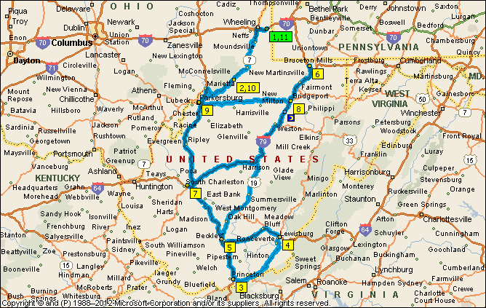
Summary: 1013.1 miles (1 day, 7 hours, 42 minutes)
DAY 1
Time | Mile | Instruction | For | Toward
9:00 AM | 0.0 | Depart 6 Cabela Dr, Triadelphia, WV 26059 on Ramp (South-East) | 0.6 mi | I-70 W / Wheeling
9:01 AM | 0.6 | Merge onto I-70 | 4.0 mi
9:05 AM | 4.5 | At exit 5A, take Ramp (LEFT) onto I-470 | 4.3 mi | I-470 W / Columbus
9:09 AM | 8.5 | Entering Ohio
9:09 AM | 8.8 | At exit 6, turn RIGHT onto Ramp | 0.5 mi | OH-7 / Bridgeport / Bellaire
9:09 AM | 9.3 | Take Ramp (RIGHT) onto OH-7 [Jefferson St] | 34.1 mi | OH-7 S / Bellaire
9:45 AM | 43.4 | Turn LEFT (East) onto Local road(s) | 43 yds
9:45 AM | 43.4 | Bear LEFT (North) onto OH-7 | 0.2 mi
9:45 AM | 43.7 | Entering West Virginia
9:45 AM | 43.7 | Road name changes to WV-7 | 0.3 mi
9:46 AM | 44.0 | Take Ramp (RIGHT) onto WV-2 [WV-7] | 10.9 mi | WV-2 S / Parkersburg / Downtown
10:00 AM | 54.9 | Turn LEFT (South) onto WV-2 [Elizabeth St] | 87 yds
10:00 AM | 55.0 | Turn RIGHT (South-West) onto WV-2 [Chelsea St] | 0.1 mi
10:00 AM | 55.1 | Keep STRAIGHT onto WV-18 [WV-2] | 0.9 mi
10:02 AM | 56.0 | Bear RIGHT (South) onto WV-2 | 4.1 mi
10:07 AM | 60.1 | At Friendly, stay on WV-2 [Orchard St] (South-West) | 12.6 mi
10:22 AM | 72.7 | Turn RIGHT (North-West) onto WV-807 [St Marys Bridge] | 0.3 mi
10:23 AM | 73.0 | Entering Ohio
10:23 AM | 73.0 | Road name changes to OH-807 [St Marys Bridge] | 0.4 mi
10:24 AM | 73.4 | Turn RIGHT (South-West) onto OH-7 [Ohio River Scenic Byway] | 14.9 mi
10:39 AM | 88.3 | Take Ramp (LEFT) onto I-77 | 86.8 mi | I-77 S / Parkersburg
10:40 AM | 88.8 | Entering West Virginia
11:53 AM | 175.1 | Road name changes to I-64 [I-77] | 16.1 mi
12:07 PM | 191.2 | *Toll road* At exit 85, stay on I-64 [I-77] (South-East) | 44.0 mi
12:48 PM | 235.2 | *Toll road* Keep RIGHT onto I-77 [West Virginia Tpke] | 12.3 mi | I-77 S / Bluefield
12:58 PM | 247.6 | Stay on I-77 [West Virginia Tpke] (South) | 19.3 mi
1:14 PM | 266.9 | At exit 9, turn RIGHT onto Ramp | 0.4 mi | US-460 / Princeton / Pearisburg VA
1:15 PM | 267.3 | Turn RIGHT (West) onto US-460 | 0.3 mi | US-460 W / Princeton
1:15 PM | 267.6 | Turn RIGHT (North) onto WV-104 [CR-27/3] | 87 yds
1:16 PM | 267.7 | Turn LEFT (West) onto WV-104 [Oakvale Rd] | 0.1 mi
1:16 PM | 267.8 | At 751 Oakvale Rd, Princeton, WV 24740, return East on WV-104 [Oakvale Rd] | 0.1 mi
1:16 PM | 267.9 | Turn RIGHT (South) onto WV-104 [CR-27/3] | 109 yds
1:16 PM | 267.9 | Turn LEFT (East) onto US-460 | 15.1 mi
1:27 PM | 279.8 | Entering Virginia
1:30 PM | 283.0 | Turn LEFT (East) onto US-219 [Island St] | 153 yds
1:31 PM | 283.1 | Turn RIGHT (South) onto US-219 [Old Virginia Ave] | 109 yds
1:31 PM | 283.2 | Turn LEFT (East) onto US-219 [Federal St] | 26.2 mi
1:33 PM | 284.8 | Entering West Virginia
1:58 PM | 309.4 | Turn LEFT (North) onto US-219 [Main St] | 16.0 mi
2:15 PM | 325.3 | Turn LEFT (North) onto US-219 [Frankford Rd] | 5.5 mi
2:24 PM | 330.8 | At 540 N Jefferson St, Lewisburg, WV 24901, stay on US-219 [Seneca Trail] (North-East) | 0.3 mi
2:24 PM | 331.0 | Take Ramp (LEFT) onto I-64 | 45.4 mi | I-64 W / Beckley
3:02 PM | 376.5 | *Toll road* At exit 124, stay on I-64 (West) | 8.4 mi
3:10 PM | 384.9 | *Toll road* At exit 44, turn RIGHT onto Ramp | 0.5 mi | WV-3 / Harper Rd. / Beckley
3:10 PM | 385.4 | Turn LEFT (North-West) onto WV-3 [Harper Rd] | 0.3 mi | WV-3 W / Whitesville
3:11 PM | 385.7 | At 2100 Harper Rd, Beckley, WV 25801, return South-East on WV-3 [Harper Rd] | 0.3 mi
3:11 PM | 385.9 | *Toll road* Take Ramp (LEFT) onto I-64 [I-77] | 2.9 mi | I-77 N / I-64 W / Charleston
3:14 PM | 388.8 | *Toll road* At exit 48, turn RIGHT onto Ramp | 0.5 mi | US-19 / Summersville / North Beckley
3:15 PM | 389.3 | *Toll road* Merge onto US-19 ALT | 1.5 mi
3:16 PM | 390.8 | Road name changes to US-19 [Mountaineer Expy] | 66.8 mi
4:15 PM | 457.6 | Take Ramp (RIGHT) onto I-79 [US-19] | 52.7 mi | US-19 N / I-79 N / Clarksburg
5:00 PM | 510.3 | End of day

DAY 2
Time | Mile | Instruction | For | Toward
9:00 AM | 510.3 | Stay on I-79 | 44.1 mi
9:37 AM | 554.4 | At exit 155, turn RIGHT onto Ramp | 0.2 mi | WV-7 / West Virginia University
9:37 AM | 554.6 | Keep LEFT to stay on Ramp | 109 yds | CR-19/24 / Chaplin Hill Rd
9:37 AM | 554.7 | Turn RIGHT (East) onto CR-19/24 [Chaplin Hill Rd] | 0.5 mi
9:38 AM | 555.2 | At 1 Chaplin Rd, Morgantown, WV 26501, return South-West on CR-19/24 [Chaplin Hill Rd] | 0.6 mi
9:38 AM | 555.8 | Keep RIGHT onto Ramp | 0.2 mi | I-79 S / Fairmont
9:39 AM | 556.0 | Take Ramp (RIGHT) onto I-79 | 153.8 mi
11:49 AM | 709.8 | Take Ramp (RIGHT) onto I-77 | 2.2 mi | I-77 S / I-64 / Charleston
11:51 AM | 712.0 | Keep RIGHT onto Local road(s) | 0.4 mi | I-64 W / US-119 S / Huntington
11:51 AM | 712.4 | Road name changes to I-64 | 2.9 mi
11:54 AM | 715.3 | At exit 56, turn RIGHT onto Ramp | 0.2 mi | Montrose Dr.
11:54 AM | 715.5 | Turn RIGHT (North) onto Montrose Dr | 0.2 mi
11:54 AM | 715.7 | Turn LEFT (West) onto US-60 [Maccorkle Ave SW] | 0.4 mi | US-60 W
11:56 AM | 716.0 | At 400 Maccorkle Ave SW, Charleston, WV 25303, return East on US-60 [Maccorkle Ave SW] | 0.4 mi
11:56 AM | 716.4 | Turn RIGHT (South) onto Montrose Dr | 0.3 mi
11:57 AM | 716.7 | Take Ramp (LEFT) onto I-64 | 3.1 mi | I-64 E / Charleston
12:00 PM | 719.8 | At exit 59, take Ramp onto I-77 | 1.9 mi | I-77 N / I-79 / Parkersburg
12:02 PM | 721.7 | At exit 104, take Ramp (RIGHT) onto I-79 | 118.4 mi | I-79 N / Clarksburg
1:42 PM | 840.2 | At exit 119, turn RIGHT onto Ramp | 0.5 mi | US-50 / Clarksburg / Bridgeport
1:43 PM | 840.6 | Keep RIGHT to stay on Ramp | 54 yds
1:43 PM | 840.7 | Turn RIGHT (North-East) onto US-50 | 0.9 mi | US-50 E / Bridgeport
1:44 PM | 841.6 | At 809 W Main St, Bridgeport, WV 26330, return West on US-50 [W Main St] | 73.6 mi
2:48 PM | 915.2 | Keep RIGHT onto Ramp | 0.2 mi | WV-618 / 7th Street
2:48 PM | 915.4 | Bear RIGHT (West) onto WV-618 [E 7th St] | 32 yds
2:48 PM | 915.4 | Keep STRAIGHT onto WV-618 [7th St] | 1.9 mi
2:51 PM | 917.4 | Road name changes to 7th St | 10 yds
2:52 PM | 917.4 | At 7th St, Parkersburg, WV 26101, return East on 7th St | 10 yds
2:52 PM | 917.4 | Road name changes to WV-618 [7th St] | 0.2 mi
2:53 PM | 917.6 | Keep RIGHT onto WV-47 [Staunton Ave] | 0.9 mi
2:55 PM | 918.5 | Take Ramp (RIGHT) onto US-50 | 2.2 mi | US-50 E
2:57 PM | 920.7 | Turn LEFT (North) onto Local road(s) | 10 yds
2:57 PM | 920.7 | Take Ramp onto I-77 [WV-2] | 3.3 mi | WV-2 N / I-77 N / Marietta
3:00 PM | 924.0 | At exit 179, turn RIGHT onto Ramp | 0.3 mi | WV-2 N / WV-68 S / Emerson Ave. / Vienna
3:01 PM | 924.4 | Keep RIGHT to stay on Ramp | 32 yds
3:01 PM | 924.4 | Keep RIGHT to stay on Ramp | 43 yds
3:01 PM | 924.4 | Bear RIGHT (East) onto WV-2 [Emerson Ave] | 28.4 mi | WV-2 N / St. Marys
3:35 PM | 952.8 | At Friendly, stay on WV-2 [Orchard St] (North-East) | 4.1 mi
3:40 PM | 957.0 | Bear LEFT (North) onto WV-18 [WV-2] | 0.9 mi
3:41 PM | 957.9 | Keep STRAIGHT onto WV-2 [Chelsea St] | 0.1 mi
3:41 PM | 958.0 | Turn LEFT (North-West) onto WV-2 [Elizabeth St] | 87 yds
3:41 PM | 958.0 | Turn RIGHT (North-East) onto WV-2 [N Wells St] | 10.7 mi
3:56 PM | 968.7 | Keep RIGHT onto Ramp | 0.2 mi | OH-7
3:56 PM | 969.0 | Road name changes to WV-7 | 0.4 mi
3:57 PM | 969.4 | Entering Ohio
3:57 PM | 969.4 | Road name changes to OH-7 | 33.9 mi
4:32 PM | 1003.3 | Keep LEFT onto Ramp | 0.2 mi | I-470 / Columbus / Washington Pa
4:32 PM | 1003.6 | Turn LEFT (West) onto Local road(s) | 10 yds
4:32 PM | 1003.6 | Keep STRAIGHT onto Ramp | 142 yds | I-470 / Columbus / Washington Pa
4:32 PM | 1003.7 | Take Ramp (RIGHT) onto I-470 | 4.2 mi | I-470 E / Washington Pa / Wheeling W VA
4:33 PM | 1004.1 | Entering West Virginia
4:36 PM | 1007.9 | Take Ramp onto I-70 | 4.7 mi | I-70 E
4:40 PM | 1012.6 | At exit 10, turn RIGHT onto Ramp | 0.2 mi | CR-65 / Cabela Dr.
4:41 PM | 1012.8 | Keep RIGHT to stay on Ramp | 0.1 mi
4:41 PM | 1013.0 | Bear RIGHT (West) onto CR-65 [Cabela Dr] | 0.2 mi
4:42 PM | 1013.1 | Arrive 6 Cabela Dr, Triadelphia, WV 26059

SUMMARY
Driving distance: 1013.1 miles
Trip duration: 1 day, 7 hours, 42 minutes
Driving time: 15 hours, 42 minutes
Cost: $112.58

Western BBG and BB
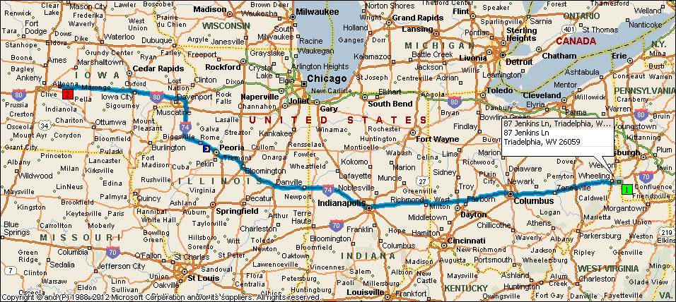
Summary: 762.0 miles (1 day, 3 hours, 2 minutes)
DAY 1
Time | Mile | Instruction | For | Toward
 |  | Check your departure time; the next stop is in a different time zone.
9:00 AM | 0.0 | Depart 87 Jenkins Ln, Triadelphia, WV 26059 on CR-41/2 [Jenkins Ln] (North) | 0.1 mi
9:00 AM | 0.1 | Turn RIGHT (East) onto Ramp | 0.2 mi
9:00 AM | 0.3 | Turn LEFT (West) onto CR-41 [Dallas Pike Rd] | 0.1 mi
9:00 AM | 0.5 | Take Ramp (LEFT) onto I-70 | 5.9 mi | I-70 W / Wheeling
9:06 AM | 6.3 | At exit 5A, take Ramp (LEFT) onto I-470 | 10.6 mi | I-470 W / Columbus
9:10 AM | 10.3 | Entering Ohio
9:15 AM | 17.0 | At exit 1, take Ramp (LEFT) onto I-70 | 39.5 mi | I-70 W / Columbus
9:49 AM | 56.5 | At exit 180B, take Ramp (RIGHT) onto I-77 | 2.1 mi | I-77 N / Cleveland
9:51 AM | 58.6 | At exit 46B, turn RIGHT onto Ramp | 0.4 mi | US-40 W / Cambridge
9:51 AM | 59.0 | Keep STRAIGHT onto US-40 [Wheeling Ave] | 0.4 mi
9:52 AM | 59.3 | Keep STRAIGHT onto US-40 [E Wheeling Ave] | 0.9 mi
9:54 AM | 60.2 | Turn LEFT (South-West) onto US-22 [US-40] | 2.7 mi
9:58 AM | 62.9 | Turn LEFT (South) onto OH-723 | 0.2 mi
9:59 AM | 63.2 | Take Ramp onto I-70 | 18.8 mi | I-70 W / Columbus
10:15 AM | 82.0 | At exit 157, turn off onto Ramp | 0.3 mi | OH-93 / Adamsville / Zanesville
10:15 AM | 82.3 | Turn LEFT (South) onto OH-93 [Pleasant Grove Rd] | 0.2 mi
10:15 AM | 82.4 | Turn RIGHT (West) onto US-22 [US-40] | 2.3 mi
10:19 AM | 84.7 | Turn RIGHT (North) onto OH-146 [OH-60] | 0.3 mi
10:20 AM | 85.0 | Take Ramp (LEFT) onto I-70 | 227.5 mi | I-70 W / Columbus
12:31 PM | 239.7 | Entering Indiana
1:34 PM | 312.5 | At exit 83B, take Ramp (RIGHT) onto I-65 | 1.0 mi | I-65 N / Chicago
1:36 PM | 313.5 | At exit 113, turn RIGHT onto Ramp | 0.2 mi | Pennsylvania St. / Meridian St.
1:36 PM | 313.7 | Road name changes to E 12th St | 164 yds
1:36 PM | 313.7 | Turn RIGHT (North) onto N Meridian St | 0.4 mi
1:37 PM | 314.1 | Turn LEFT (West) onto W 16th St | 3.5 mi
1:43 PM | 317.7 | Road name changes to Hulman Memorial Way [W 16th St] | 0.8 mi
1:44 PM | 318.5 | Keep RIGHT onto Crawfordsville Rd [Hulman Memorial Way] | 2.1 mi
1:47 PM | 320.5 | At exit 73B, road name changes to I-74 | 160.3 mi
2:50 PM | 394.0 | Entering Illinois
4:03 PM | 480.8 | Merge onto I-55 [I-74] | 5.6 mi
4:08 PM | 486.4 | At exit 163, take Ramp (RIGHT) onto I-74 | 59.6 mi | I-74 W / Peoria
 |  | Check local time; this stop is in a different time zone.
5:00 PM | 545.9 | End of day

DAY 2
Time | Mile | Instruction | For | Toward
9:00 AM | 545.9 | Stay on I-74 | 54.4 mi
9:45 AM | 600.4 | Road name changes to I-80 [IL-110] | 161.2 mi | I-80 W / Davenport
9:54 AM | 610.5 | Entering Iowa
12:01 PM | 761.5 | At exit 155, turn LEFT onto Ramp | 0.3 mi | IA-117 / Mingo / Colfax
12:02 PM | 761.8 | Turn RIGHT (North) onto IA-117 [N Walnut St] | 0.1 mi
12:02 PM | 762.0 | Arrive BP [1405 N Walnut St, Colfax IA 50054, United States, Tel: +(1)-515-6740702]

SUMMARY
Driving distance: 762.0 miles
Trip duration: 1 day, 3 hours, 2 minutes
Driving time: 11 hours, 2 minutes
Cost: $84.67

OutWest SS2K:
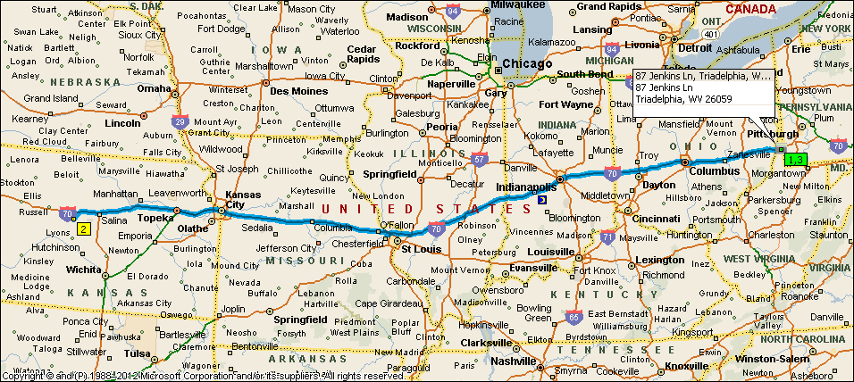
Summary: 2015.3 miles (1 day, 5 hours, 2 minutes)
DAY 1
Time | Mile | Instruction | For | Toward
 |  | Check your departure time; the next stop is in a different time zone.
4:00 AM | 0.0 | Depart 87 Jenkins Ln, Triadelphia, WV 26059 on CR-41/2 [Jenkins Ln] (North) | 0.1 mi
4:00 AM | 0.1 | Turn RIGHT (East) onto Ramp | 0.2 mi
4:00 AM | 0.3 | Turn LEFT (West) onto CR-41 [Dallas Pike Rd] | 0.1 mi
4:00 AM | 0.5 | Take Ramp (LEFT) onto I-70 | 5.9 mi | I-70 W / Wheeling
4:06 AM | 6.3 | At exit 5A, take Ramp (LEFT) onto I-470 | 10.6 mi | I-470 W / Columbus
4:10 AM | 10.3 | Entering Ohio
4:15 AM | 17.0 | At exit 1, take Ramp (LEFT) onto I-70 | 39.5 mi | I-70 W / Columbus
4:49 AM | 56.5 | At exit 180B, take Ramp (RIGHT) onto I-77 | 2.1 mi | I-77 N / Cleveland
4:51 AM | 58.6 | At exit 46B, turn RIGHT onto Ramp | 0.4 mi | US-40 W / Cambridge
4:51 AM | 59.0 | Keep STRAIGHT onto US-40 [Wheeling Ave] | 0.4 mi
4:52 AM | 59.3 | Keep STRAIGHT onto US-40 [E Wheeling Ave] | 0.9 mi
4:54 AM | 60.2 | Turn LEFT (South-West) onto US-22 [US-40] | 2.7 mi
4:58 AM | 62.9 | Turn LEFT (South) onto OH-723 | 0.2 mi
4:59 AM | 63.2 | Take Ramp onto I-70 | 18.8 mi | I-70 W / Columbus
5:15 AM | 82.0 | At exit 157, turn off onto Ramp | 0.3 mi | OH-93 / Adamsville / Zanesville
5:15 AM | 82.3 | Turn LEFT (South) onto OH-93 [Pleasant Grove Rd] | 0.2 mi
5:15 AM | 82.4 | Turn RIGHT (West) onto US-22 [US-40] | 2.3 mi
5:19 AM | 84.7 | Turn LEFT to stay on US-22 [US-40] | 109 yds
5:19 AM | 84.8 | Bear RIGHT (West) onto US-40 [Main St] | 54 yds
5:19 AM | 84.8 | Turn LEFT (East) onto Local road(s) | 54 yds
5:20 AM | 84.9 | Turn LEFT (North-East) onto US-22 [OH-146] | 153 yds
5:20 AM | 85.0 | Keep STRAIGHT onto OH-146 [OH-60] | 0.3 mi
5:20 AM | 85.2 | Take Ramp (LEFT) onto I-70 | 227.5 mi | I-70 W / Columbus
7:31 AM | 239.9 | Entering Indiana
8:34 AM | 312.7 | At exit 83B, turn LEFT onto Ramp | 0.1 mi | I-70 W / I-65 S
8:35 AM | 312.8 | Take Ramp (LEFT) onto I-65 [I-70] | 2.4 mi | I-65 S / I-70 W
8:38 AM | 315.3 | At exit 110B, take Ramp (RIGHT) onto I-70 | 138.9 mi | I-70 W / St. Louis
9:48 AM | 396.2 | Entering Illinois
10:37 AM | 454.2 | Merge onto I-57 [I-70] | 5.3 mi
10:42 AM | 459.5 | Keep RIGHT onto I-70 | 76.9 mi | I-70 W / St Louis
11:47 AM | 536.4 | Road name changes to I-270 | 29.7 mi | I-270 W / Kansas City
12:00 PM | 551.7 | Entering Missouri
12:14 PM | 566.1 | At exit 20A-B, turn RIGHT onto Ramp | 0.7 mi | I-70 W / I-70 E / St Louis / Kansas City
12:15 PM | 566.8 | Take Ramp (RIGHT) onto I-70 | 229.7 mi | I-70 W / Kansas City
3:33 PM | 796.5 | Keep LEFT onto I-670 [I-70 ALT] | 3.9 mi | I-670 W / I-70-ALT / I-35 S / Wichita / Topeka
3:35 PM | 798.7 | Entering Kansas
3:37 PM | 800.4 | Merge onto I-70 [US-24] | 13.4 mi
3:48 PM | 813.8 | *Toll road* At exit 224, stay on I-70 [Kansas Tpke] (West) | 42.1 mi
4:24 PM | 855.9 | Stay on I-70 [US-40] (West) | 140.1 mi
6:22 PM | 995.9 | At exit 225, turn RIGHT onto Ramp | 0.1 mi | KS-156 / Great Bend / Ellsworth
6:23 PM | 996.1 | Turn LEFT (South) onto KS-156 | 11.9 mi
6:33 PM | 1008.0 | Bear RIGHT (West) onto Ramp | 0.1 mi
6:33 PM | 1008.1 | Turn RIGHT (North) onto Blake St, then immediately turn LEFT (West) onto (NE) Main St | 0.3 mi
6:34 PM | 1008.4 | Keep STRAIGHT onto (NE) Main St [E North Main St] | 0.4 mi
6:35 PM | 1008.8 | Road name changes to (NW) Main St [W North Main St] | 120 yds
 |  | Check local time; this stop is in a different time zone.
6:36 PM | 1008.8 | At Co-Op [103 N Kansas Ave, Ellsworth KS 67439, United States, Tel: +(1)-785-4724061], return South-East on NW Main St [W North Main St] | 120 yds
 |  | Check your departure time; the next stop is in a different time zone.
6:36 PM | 1008.9 | Turn RIGHT (South-West) onto KS-14 [N Douglas Ave] | 1.2 mi
6:39 PM | 1010.1 | Turn LEFT (North-East) onto KS-156 [KS-14-TRUCK] | 13.0 mi
6:50 PM | 1023.1 | Take Ramp (RIGHT) onto I-70 [US-40] | 140.1 mi | US-40 E / I-70 E / Salina
8:49 PM | 1163.2 | *Toll road* At exit 366, stay on I-70 (East) | 42.1 mi | I-70 E / Kansas City / Kansas Turnpike East
9:25 PM | 1205.3 | Stay on I-70 [US-24] (East) | 13.4 mi
9:36 PM | 1218.6 | Keep LEFT onto I-670 [I-70 ALT] | 4.1 mi | I-670
9:38 PM | 1220.4 | Entering Missouri
9:40 PM | 1222.7 | Merge onto I-70 [US-40] | 229.1 mi
12:57 AM | 1451.8 | At exit 232, turn RIGHT onto Ramp | 0.2 mi | I-270 / Chicago / Memphis
12:57 AM | 1452.0 | Keep LEFT to stay on Ramp | 0.7 mi | I-270 N / Chicago
12:58 AM | 1452.7 | Take Ramp (LEFT) onto I-270 | 30.0 mi | I-270 N / Chicago
1:12 AM | 1467.6 | Entering Illinois
1:26 AM | 1482.8 | Road name changes to I-70 | 77.4 mi
2:31 AM | 1560.1 | Merge onto I-57 [I-70] | 5.4 mi
2:36 AM | 1565.5 | Keep RIGHT onto I-70 | 98.3 mi | I-70 E / Indianapolis
3:24 AM | 1623.2 | Entering Indiana
 |  | Check local time; this stop is in a different time zone.
3:59 AM | 1663.8 | End of day

DAY 2
Time | Mile | Instruction | For | Toward
4:00 AM | 1663.8 | Stay on I-70 | 40.0 mi
4:35 AM | 1703.8 | At exit 80, take Ramp (LEFT) onto I-65 [I-70] | 1.8 mi | I-65 N / I-70 E / Columbus Oh.
4:38 AM | 1705.6 | Keep RIGHT onto I-70 | 293.1 mi | I-70 E / Columbus Oh.
5:41 AM | 1779.3 | Entering Ohio
8:47 AM | 1998.7 | At exit 219, take Ramp (RIGHT) onto I-470 | 10.6 mi | I-470 E / Washington Pa / Bellaire
8:53 AM | 2005.5 | Entering West Virginia
8:56 AM | 2009.2 | Take Ramp onto I-70 | 5.8 mi | I-70 E
9:01 AM | 2015.1 | At exit 11, turn LEFT onto Ramp | 0.1 mi | CR-41 / Dallas Pike
9:02 AM | 2015.2 | Turn RIGHT (South) onto CR-41/2 [Jenkins Ln] | 0.1 mi
9:02 AM | 2015.3 | Arrive 87 Jenkins Ln, Triadelphia, WV 26059

SUMMARY
Driving distance: 2015.3 miles
Trip duration: 1 day, 5 hours, 2 minutes
Driving time: 29 hours, 1 minute
Cost: $223.95

Down South BB and BBG
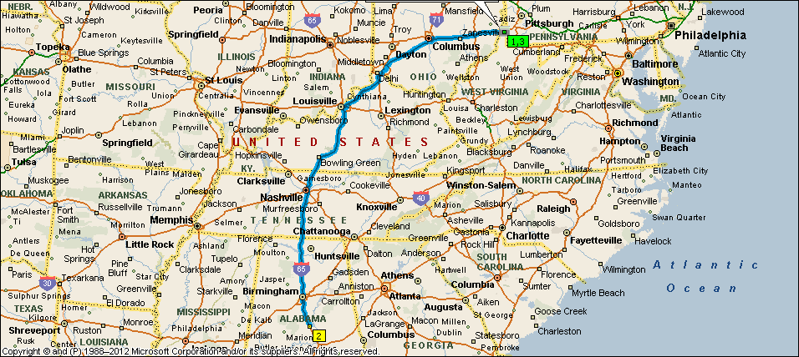
Summary: 1518.4 miles (21 hours, 51 minutes)
Time | Mile | Instruction | For | Toward
 |  | Check your departure time; the next stop is in a different time zone.
4:00 AM | 0.0 | Depart 87 Jenkins Ln, Triadelphia, WV 26059 on CR-41/2 [Jenkins Ln] (North) | 0.1 mi
4:00 AM | 0.1 | Turn RIGHT (East) onto Ramp | 0.2 mi
4:00 AM | 0.3 | Turn LEFT (West) onto CR-41 [Dallas Pike Rd] | 0.1 mi
4:00 AM | 0.5 | Take Ramp (LEFT) onto I-70 | 5.9 mi | I-70 W / Wheeling
4:06 AM | 6.3 | At exit 5A, take Ramp (LEFT) onto I-470 | 10.6 mi | I-470 W / Columbus
4:10 AM | 10.3 | Entering Ohio
4:15 AM | 17.0 | At exit 1, take Ramp (LEFT) onto I-70 | 39.5 mi | I-70 W / Columbus
4:49 AM | 56.5 | At exit 180B, take Ramp (RIGHT) onto I-77 | 2.1 mi | I-77 N / Cleveland
4:51 AM | 58.6 | At exit 46B, turn RIGHT onto Ramp | 0.4 mi | US-40 W / Cambridge
4:51 AM | 59.0 | Keep STRAIGHT onto US-40 [Wheeling Ave] | 0.4 mi
4:52 AM | 59.3 | Keep STRAIGHT onto US-40 [E Wheeling Ave] | 0.9 mi
4:54 AM | 60.2 | Turn LEFT (South-West) onto US-22 [US-40] | 2.7 mi
4:58 AM | 62.9 | Turn LEFT (South) onto OH-723 | 0.2 mi
4:59 AM | 63.2 | Take Ramp onto I-70 | 18.8 mi | I-70 W / Columbus
5:15 AM | 82.0 | At exit 157, turn off onto Ramp | 0.3 mi | OH-93 / Adamsville / Zanesville
5:15 AM | 82.3 | Turn LEFT (South) onto OH-93 [Pleasant Grove Rd] | 0.2 mi
5:15 AM | 82.4 | Turn RIGHT (West) onto US-22 [US-40] | 2.3 mi
5:19 AM | 84.7 | Turn LEFT to stay on US-22 [US-40] | 109 yds
5:19 AM | 84.8 | Bear RIGHT (West) onto US-40 [Main St] | 54 yds
5:19 AM | 84.8 | Turn LEFT (East) onto Local road(s) | 54 yds
5:20 AM | 84.9 | Turn LEFT (North-East) onto US-22 [OH-146] | 153 yds
5:20 AM | 85.0 | Keep STRAIGHT onto OH-146 [OH-60] | 0.3 mi
5:20 AM | 85.2 | Take Ramp (LEFT) onto I-70 | 49.5 mi | I-70 W / Columbus
6:02 AM | 134.7 | At exit 105A, turn RIGHT onto Ramp | 0.3 mi | US-33 / Lancaster
6:03 AM | 135.0 | Bear RIGHT (South) onto S James Rd | 0.5 mi
6:03 AM | 135.5 | Take Ramp onto US-33 | 0.5 mi
6:04 AM | 136.0 | Keep RIGHT onto Ramp | 0.2 mi | OH-104 W / Refugee Rd
6:04 AM | 136.1 | Take Ramp (RIGHT) onto OH-104 | 5.0 mi | OH-104 W / Refugee Rd West
6:09 AM | 141.1 | Keep STRAIGHT onto Frank Rd | 0.4 mi
6:09 AM | 141.5 | Take Ramp (LEFT) onto I-71 | 122.6 mi | I-71 S / Cincinnati
7:39 AM | 245.3 | Entering Kentucky
7:55 AM | 264.1 | At exit 173, take Ramp (RIGHT) onto I-71 | 71.6 mi | I-71 S / Louisville
8:56 AM | 335.7 | At exit 5, take Ramp (LEFT) onto I-264 | 10.4 mi | I-264 / Watterson Expressway
9:06 AM | 346.2 | At exit 12, turn RIGHT onto Ramp | 0.1 mi | I-65 N / I-65 S / KY-61 / Preston Highway / Nashville / Indianapolis
9:06 AM | 346.3 | Keep LEFT to stay on Ramp | 0.2 mi | I-65 S / I-65 N / Indianapolis / Downtown Louisville / Nashville
9:06 AM | 346.5 | Take Ramp (LEFT) onto I-65 | 165.0 mi | I-65 S / Nashville
10:58 AM | 478.2 | Entering Tennessee
11:27 AM | 511.5 | Road name changes to I-24 [I-65] | 4.6 mi
11:31 AM | 516.1 | At exit 50B, take Ramp (RIGHT) onto I-40 | 1.0 mi | I-40 W / I-65 S / Memphis / Huntsville
11:32 AM | 517.1 | At exit 210B, take Ramp (LEFT) onto I-65 | 243.9 mi | I-65 S / Huntsville
12:43 PM | 600.1 | Entering Alabama
3:01 PM | 761.1 | At exit 205, turn RIGHT onto Ramp | 0.2 mi | AL-22 / US-31 / Clanton
3:01 PM | 761.3 | Keep RIGHT to stay on Ramp | 87 yds | AL-22 / US-31 / Clanton
3:01 PM | 761.4 | Keep STRAIGHT onto US-31 [AL-22] | 0.2 mi
 |  | Check local time; this stop is in a different time zone.
3:01 PM | 761.6 | At BP [2131 7th St S, Clanton AL 35045, United States, Tel: +(1)-205-7553283], return East on US-31 [AL-22] | 0.4 mi
 |  | Check your departure time; the next stop is in a different time zone.
3:02 PM | 762.0 | Take Ramp (LEFT) onto I-65 | 244.0 mi | I-65 N / Birmingham
5:21 PM | 923.4 | Entering Tennessee
6:31 PM | 1005.9 | At exit 82A, take Ramp (RIGHT) onto I-40 | 1.0 mi | I-40 E / Knoxville
6:32 PM | 1006.9 | At exit 211B, take Ramp (LEFT) onto I-24 | 5.0 mi | I-24 W / I-65 N / Clarksville / Louisville
6:37 PM | 1011.9 | Keep RIGHT onto I-65 | 163.3 mi | I-65 N / Louisville
7:05 PM | 1045.1 | Entering Kentucky
8:55 PM | 1175.3 | At exit 131-A, turn RIGHT onto Ramp | 0.5 mi | I-264 / Watterson Expressway / Airport
8:55 PM | 1175.8 | Take Ramp (RIGHT) onto I-264 [US-60] | 10.8 mi | I-264 E / Watterson Expressway
9:06 PM | 1186.6 | At exit 23B, take Ramp (RIGHT) onto I-71 | 71.7 mi | I-71 N / Cincinnati
10:06 PM | 1258.3 | Take Ramp onto I-71 [I-75] | 120.3 mi
10:24 PM | 1277.5 | Entering Ohio
11:51 PM | 1378.6 | At exit 101, turn RIGHT onto Ramp | 0.2 mi | I-270 / Wheeling / Dayton
11:51 PM | 1378.8 | Take Ramp (RIGHT) onto I-270 | 12.0 mi | I-270 E / Wheeling
12:01 AM | 1390.8 | At exit 41-43A-B, turn RIGHT onto Ramp | 0.2 mi | US-40 / I-70 W / I-70 E / Wheeling / Columbus / Main Street
12:02 AM | 1390.9 | Take Ramp (RIGHT) onto I-70 | 110.7 mi | I-70 E / Wheeling
1:36 AM | 1501.7 | At exit 219, take Ramp (RIGHT) onto I-470 | 10.6 mi | I-470 E / Washington Pa / Bellaire
1:41 AM | 1508.5 | Entering West Virginia
1:45 AM | 1512.3 | Take Ramp onto I-70 | 5.8 mi | I-70 E
1:50 AM | 1518.1 | At exit 11, turn LEFT onto Ramp | 0.1 mi | CR-41 / Dallas Pike
1:50 AM | 1518.2 | Turn RIGHT (South) onto CR-41/2 [Jenkins Ln] | 0.1 mi
 |  | Check local time; this stop is in a different time zone.
1:51 AM | 1518.4 | Arrive 87 Jenkins Ln, Triadelphia, WV 26059

SUMMARY
Driving distance: 1518.4 miles
Trip duration: 21 hours, 51 minutes
Driving time: 21 hours, 51 minutes
Cost: $168.72

Downsouth SS2K:
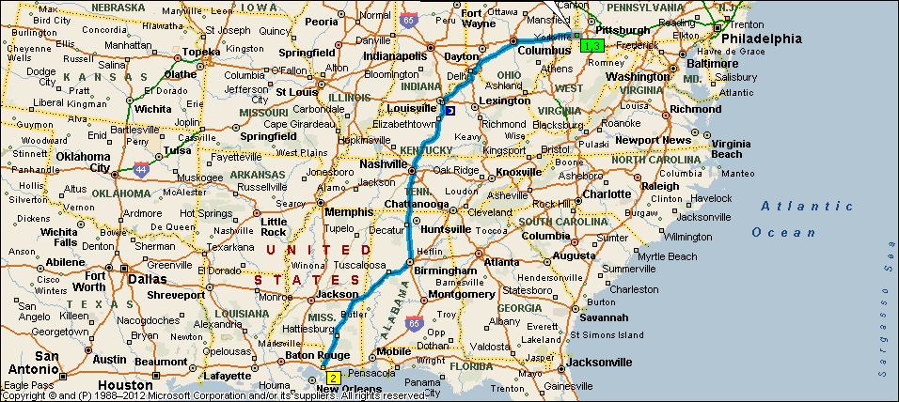
Summary: 2017.4 miles (1 day, 4 hours, 56 minutes)
DAY 1
Time | Mile | Instruction | For | Toward
 |  | Check your departure time; the next stop is in a different time zone.
4:00 AM | 0.0 | Depart 87 Jenkins Ln, Triadelphia, WV 26059 on CR-41/2 [Jenkins Ln] (North) | 0.1 mi
4:00 AM | 0.1 | Turn RIGHT (East) onto Ramp | 0.2 mi
4:00 AM | 0.3 | Turn LEFT (West) onto CR-41 [Dallas Pike Rd] | 0.1 mi
4:00 AM | 0.5 | Take Ramp (LEFT) onto I-70 | 5.9 mi | I-70 W / Wheeling
4:06 AM | 6.3 | At exit 5A, take Ramp (LEFT) onto I-470 | 10.6 mi | I-470 W / Columbus
4:10 AM | 10.3 | Entering Ohio
4:15 AM | 17.0 | At exit 1, take Ramp (LEFT) onto I-70 | 39.5 mi | I-70 W / Columbus
4:49 AM | 56.5 | At exit 180B, take Ramp (RIGHT) onto I-77 | 2.1 mi | I-77 N / Cleveland
4:51 AM | 58.6 | At exit 46B, turn RIGHT onto Ramp | 0.4 mi | US-40 W / Cambridge
4:51 AM | 59.0 | Keep STRAIGHT onto US-40 [Wheeling Ave] | 0.4 mi
4:52 AM | 59.3 | Keep STRAIGHT onto US-40 [E Wheeling Ave] | 0.9 mi
4:54 AM | 60.2 | Turn LEFT (South-West) onto US-22 [US-40] | 2.7 mi
4:58 AM | 62.9 | Turn LEFT (South) onto OH-723 | 0.2 mi
4:59 AM | 63.2 | Take Ramp onto I-70 | 18.8 mi | I-70 W / Columbus
5:15 AM | 82.0 | At exit 157, turn off onto Ramp | 0.3 mi | OH-93 / Adamsville / Zanesville
5:15 AM | 82.3 | Turn LEFT (South) onto OH-93 [Pleasant Grove Rd] | 0.2 mi
5:15 AM | 82.4 | Turn RIGHT (West) onto US-22 [US-40] | 2.3 mi
5:19 AM | 84.7 | Turn RIGHT (North) onto OH-146 [OH-60] | 0.3 mi
5:20 AM | 85.0 | Take Ramp (LEFT) onto I-70 | 49.5 mi | I-70 W / Columbus
6:02 AM | 134.5 | At exit 105A, turn RIGHT onto Ramp | 0.3 mi | US-33 / Lancaster
6:03 AM | 134.8 | Bear RIGHT (South) onto S James Rd | 0.5 mi
6:03 AM | 135.3 | Take Ramp onto US-33 | 0.5 mi
6:04 AM | 135.7 | Keep RIGHT onto Ramp | 0.2 mi | OH-104 W / Refugee Rd
6:04 AM | 135.9 | Take Ramp (RIGHT) onto OH-104 | 5.0 mi | OH-104 W / Refugee Rd West
6:09 AM | 140.9 | Keep STRAIGHT onto Frank Rd | 0.4 mi
6:09 AM | 141.3 | Take Ramp (LEFT) onto I-71 | 122.6 mi | I-71 S / Cincinnati
7:39 AM | 245.1 | Entering Kentucky
7:55 AM | 263.9 | At exit 173, take Ramp (RIGHT) onto I-71 | 71.6 mi | I-71 S / Louisville
8:56 AM | 335.5 | At exit 5, take Ramp (LEFT) onto I-264 | 10.4 mi | I-264 / Watterson Expressway
9:06 AM | 345.9 | At exit 12, turn RIGHT onto Ramp | 0.1 mi | I-65 N / I-65 S / KY-61 / Preston Highway / Nashville / Indianapolis
9:06 AM | 346.1 | Keep LEFT to stay on Ramp | 0.2 mi | I-65 S / I-65 N / Indianapolis / Downtown Louisville / Nashville
9:06 AM | 346.3 | Take Ramp (LEFT) onto I-65 | 165.0 mi | I-65 S / Nashville
10:58 AM | 478.0 | Entering Tennessee
11:27 AM | 511.3 | Road name changes to I-24 [I-65] | 4.6 mi
11:31 AM | 515.9 | At exit 50B, take Ramp (RIGHT) onto I-40 | 1.0 mi | I-40 W / I-65 S / Memphis / Huntsville
11:32 AM | 516.9 | At exit 210B, take Ramp (LEFT) onto I-65 | 188.6 mi | I-65 S / Huntsville
12:43 PM | 599.9 | Entering Alabama
2:12 PM | 705.6 | At exit 261B, take Ramp (RIGHT) onto I-20 [I-59] | 148.4 mi | I-20 W / I-59 S / Tuscaloosa
3:59 PM | 830.5 | Entering Mississippi
4:19 PM | 853.9 | Take Ramp (LEFT) onto I-59 | 156.6 mi | I-59 S / Laurel / New Orleans
6:26 PM | 1002.6 | Entering Louisiana
6:32 PM | 1010.5 | At exit 3, turn RIGHT onto Ramp | 0.3 mi | LA-1090 S / US-11 S / Pearl River
6:33 PM | 1010.7 | Turn RIGHT (West) onto LA-1090 [Concord Blvd] | 0.1 mi
 |  | Check local time; this stop is in a different time zone.
6:33 PM | 1010.8 | At Shell [63525 Highway 1090, Pearl River LA 70452, United States, Tel: +(1)-985-8637722], return East on LA-1090 [Concord Blvd] | 0.4 mi
 |  | Check your departure time; the next stop is in a different time zone.
6:33 PM | 1011.3 | Take Ramp (LEFT) onto I-59 | 156.5 mi | I-59 N / Hattiesburg
6:41 PM | 1019.6 | Entering Mississippi
8:47 PM | 1167.7 | At exit 149, take Ramp (RIGHT) onto I-20 [I-59] | 148.6 mi | I-59 N / I-20 E / Tuscaloosa / Meridian
9:08 PM | 1191.5 | Entering Alabama
10:54 PM | 1316.3 | At exit 124B, take Ramp (LEFT) onto I-65 | 188.6 mi | I-65 N / Huntsville
12:25 AM | 1422.4 | Entering Tennessee
1:35 AM | 1504.9 | At exit 82A, take Ramp (RIGHT) onto I-40 | 1.0 mi | I-40 E / Knoxville
1:36 AM | 1505.9 | At exit 211B, take Ramp (LEFT) onto I-24 | 5.0 mi | I-24 W / I-65 N / Clarksville / Louisville
1:41 AM | 1510.9 | Keep RIGHT onto I-65 | 163.1 mi | I-65 N / Louisville
2:09 AM | 1544.1 | Entering Kentucky
 |  | Check local time; this stop is in a different time zone.
3:59 AM | 1674.1 | End of day

DAY 2
Time | Mile | Instruction | For | Toward
4:00 AM | 1674.1 | Stay on I-65 | 0.2 mi | I-65 N / Louisville / Fair/Expo Ctr / Indianapolis
4:00 AM | 1674.3 | At exit 131-A, turn RIGHT onto Ramp | 0.5 mi | I-264 / Watterson Expressway / Airport
4:00 AM | 1674.8 | Take Ramp (RIGHT) onto I-264 [US-60] | 10.8 mi | I-264 E / Watterson Expressway
4:11 AM | 1685.6 | At exit 23B, take Ramp (RIGHT) onto I-71 | 71.7 mi | I-71 N / Cincinnati
5:11 AM | 1757.3 | Take Ramp onto I-71 [I-75] | 120.3 mi
5:29 AM | 1776.4 | Entering Ohio
6:56 AM | 1877.6 | At exit 101, turn RIGHT onto Ramp | 0.2 mi | I-270 / Wheeling / Dayton
6:56 AM | 1877.8 | Take Ramp (RIGHT) onto I-270 | 12.0 mi | I-270 E / Wheeling
7:06 AM | 1889.7 | At exit 41-43A-B, turn RIGHT onto Ramp | 0.2 mi | US-40 / I-70 W / I-70 E / Wheeling / Columbus / Main Street
7:07 AM | 1889.9 | Take Ramp (RIGHT) onto I-70 | 110.7 mi | I-70 E / Wheeling
8:41 AM | 2000.7 | At exit 219, take Ramp (RIGHT) onto I-470 | 10.6 mi | I-470 E / Washington Pa / Bellaire
8:46 AM | 2007.5 | Entering West Virginia
8:50 AM | 2011.3 | Take Ramp onto I-70 | 5.8 mi | I-70 E
8:55 AM | 2017.1 | At exit 11, turn LEFT onto Ramp | 0.1 mi | CR-41 / Dallas Pike
8:55 AM | 2017.2 | Turn RIGHT (South) onto CR-41/2 [Jenkins Ln] | 0.1 mi
8:56 AM | 2017.4 | Arrive 87 Jenkins Ln, Triadelphia, WV 26059

SUMMARY
Driving distance: 2017.4 miles
Trip duration: 1 day, 4 hours, 56 minutes
Driving time: 28 hours, 55 minutes
Cost: $224.17

